Lab Assignment 4
VIDHU SREE DAYYALA – 2303A52400 – B41
Task 1: Sentiment Classification for Customer Reviews
Prompt used:
a) #Generate the python code in which classify the sentiment of each customer review as Positive, Negative, or Neutral Take total 6 customer reviews as input and print the sentiment classification for each review.
Code:
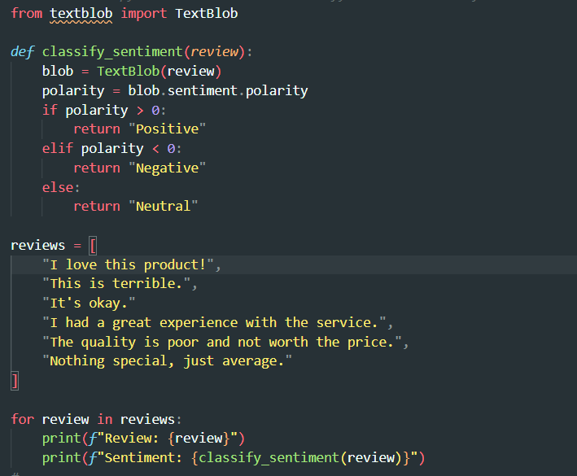

Output:
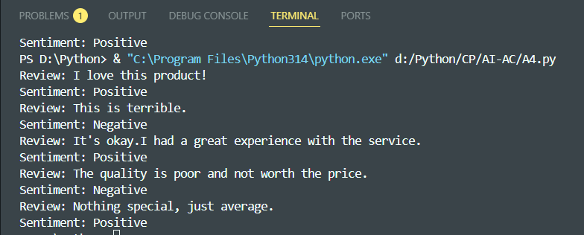
Justification:
In this task, customer reviews are clearly mapped to Positive, Negative, and Neutral sentiments based on the emotions and opinions expressed. Reviews showing satisfaction, happiness, or praise are labeled as Positive. Reviews expressing complaints, dissatisfaction, or bad experience are labeled as Negative. Reviews that are balanced, average, or emotionless are labeled as Neutral.
# Zero-shot sentiment classification (simulated)
Code:
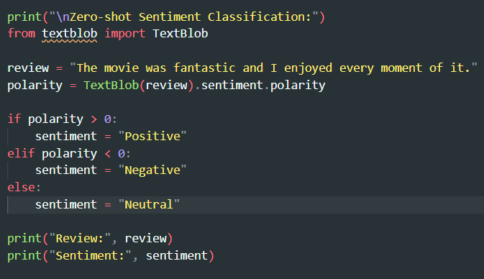

Output:
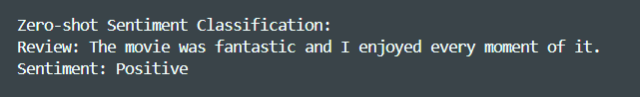
Justification:
The zero-shot prompt classifies sentiment without giving any prior examples. The model relies only on its general understanding of language and emotions. This approach is useful when quick classification is needed and no labeled data is available.
# One-shot sentiment classification. based on the previous code
Code:
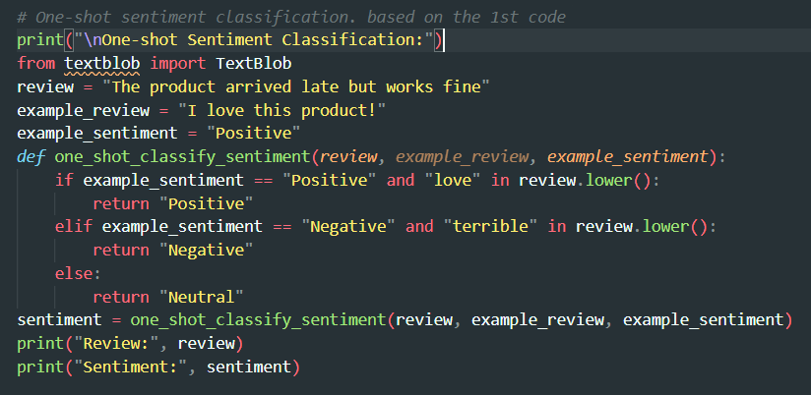
Output:
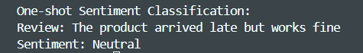
Justification:
In the one-shot prompt, one labeled example is provided to guide the model. This example helps the model understand the expected format and sentiment logic before classifying a new review.

Task 2: Email Priority Classification
Prompt used:
#Generate the python code in which classify the priority of each e-mail into into High Priority, Medium Priority, or Low Priority.
Code:
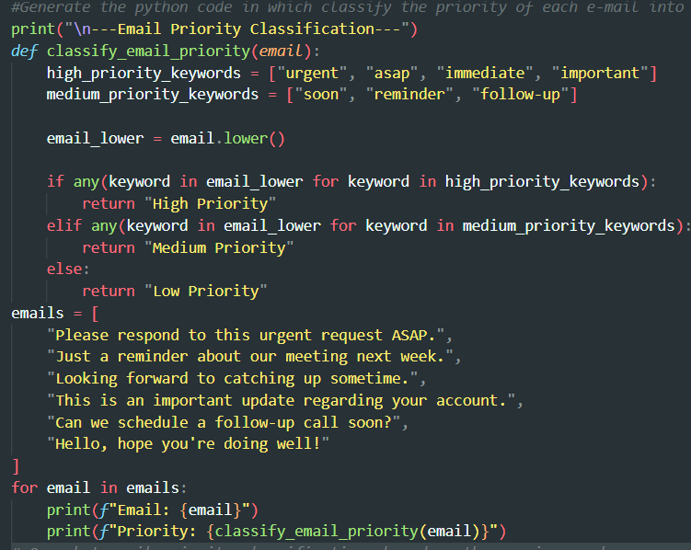
Output:
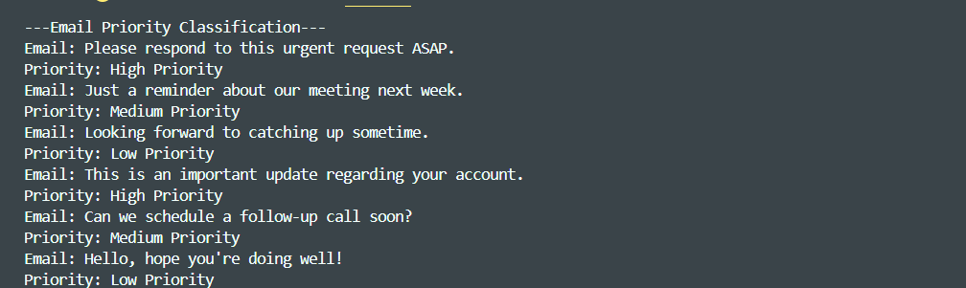

Justification:
This program classifies emails based on the urgency of words used in the message. Emails containing keywords like urgent, ASAP, or important are marked as High Priority, while reminder-related words are marked as Medium Priority. If no urgency-related keywords are found, the email is considered Low Priority.

# One-shot email priority classification. based on the previous code
Code:
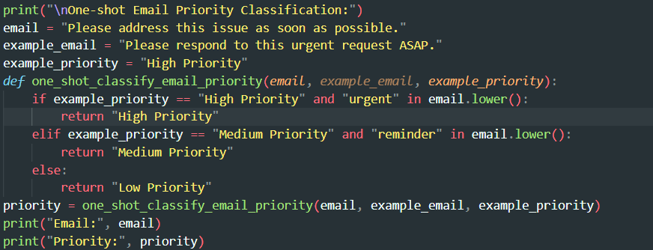
Output:
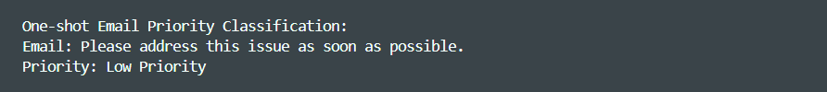
Justification:
In one-shot prompting, one labeled example is provided to guide the classification. This example helps the model understand how urgency maps to email priority. As a result, the system can classify new emails more accurately than without examples.

# few-shot email priority classification. based on the previous code.
Code:
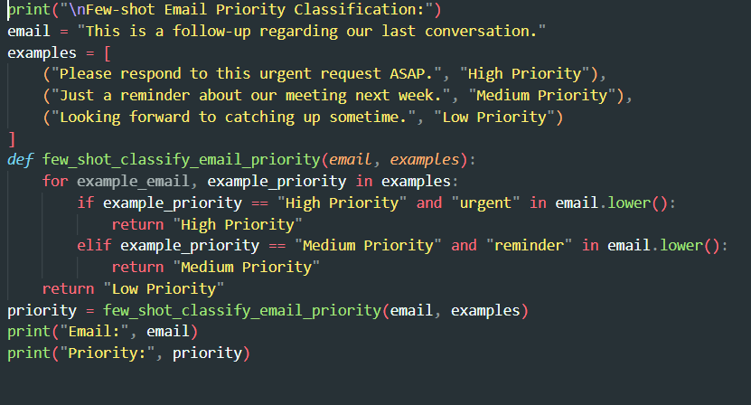
Output:
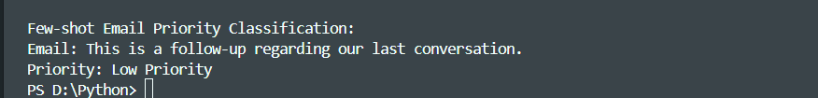
Justification:
Few-shot prompting uses multiple examples covering different priority levels.These examples give clearer context and improve consistency in classification.This method is more reliable when emails have similar or overlapping urgency.
Task 3: Student Query Routing System
Prompt used:
#Generate the python code in which classify student queries into one of these departments like Admissions, Exams, Academics, or Placements.
Code:
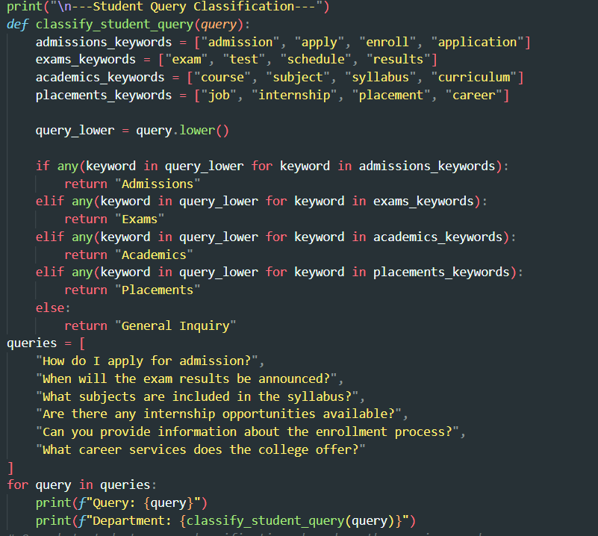
Output: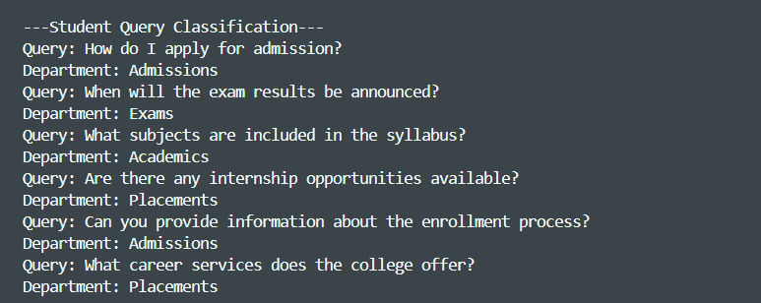

Justification:
Sample student queries are created to reflect common questions asked in a university. Each query is mapped to the appropriate department based on its intent. This helps the chatbot understand how different types of student questions should be routed. It ensures students are directed to the correct department quickly
# One-shot student query classification. based on the previous code
Code:
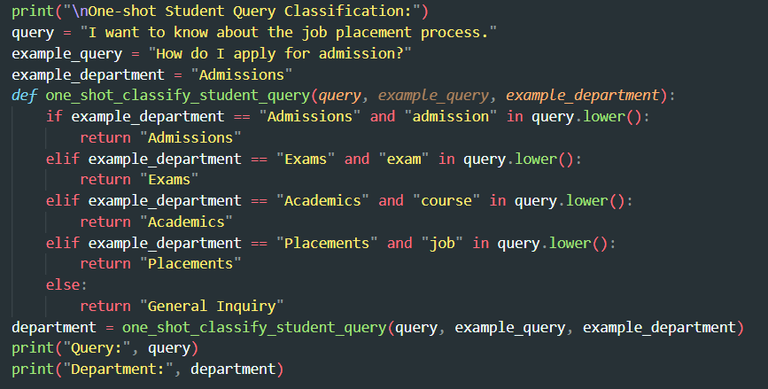
Output:
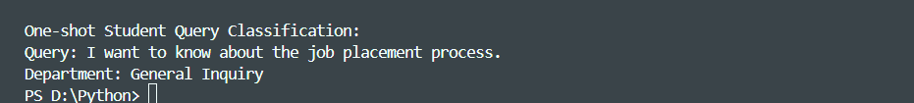
Justification:
One-shot prompting uses a single labeled example to guide query classification. The example helps the model learn how to match a student’s question with the right department. This improves routing accuracy compared to having no examples. It makes the chatbot more reliable in handling student queries.

Task 4: Chatbot Question Type Detection
Prompt used:
#Generate the python code in which identify whether a user query is Informational,Transactional, Complaint, or Feedback.
Code:
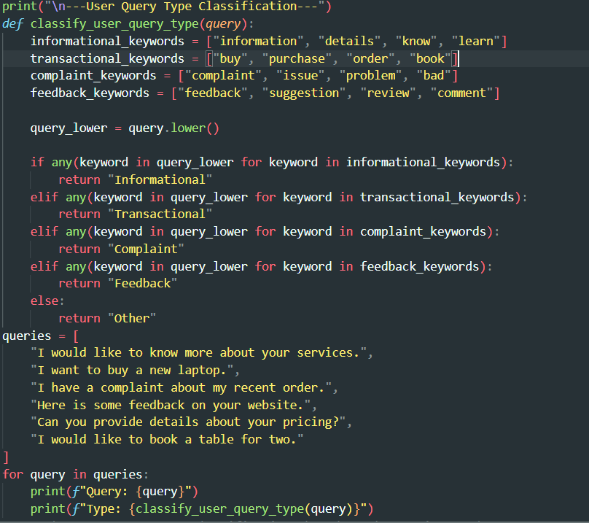
Output:
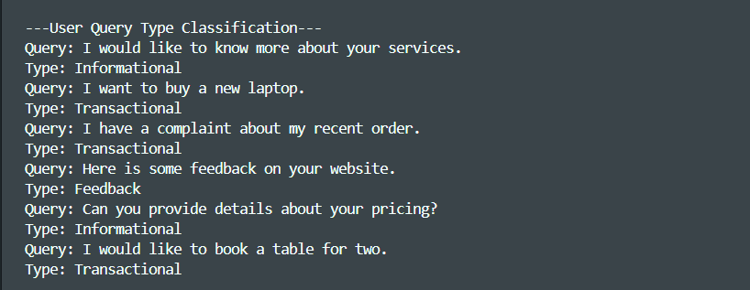
Justification:
This program identifies the type of user query using keyword matching.
It classifies queries as Informational, Transactional, Complaint, or Feedback based on intent.This helps route user requests quickly and efficiently.
# Few-shot user query type classification. based on the previous code.
Code:
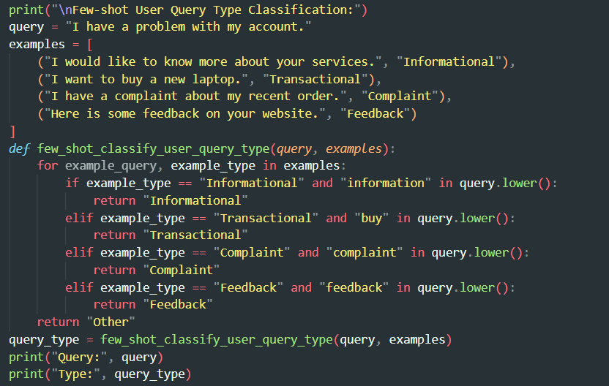
Output:
Justification:
This program uses multiple labeled examples to guide query classification.
It compares the new query with known example intents using keywords.
This improves intent identification compared to having no examples. It helps the system respond more accurately to user requests.

Task 5: Emotion Detection in Text
Prompt used:
#Generate the python code in which it detects emotions like Happy, Sad, Angry,Anxious, Neutral.
Code:
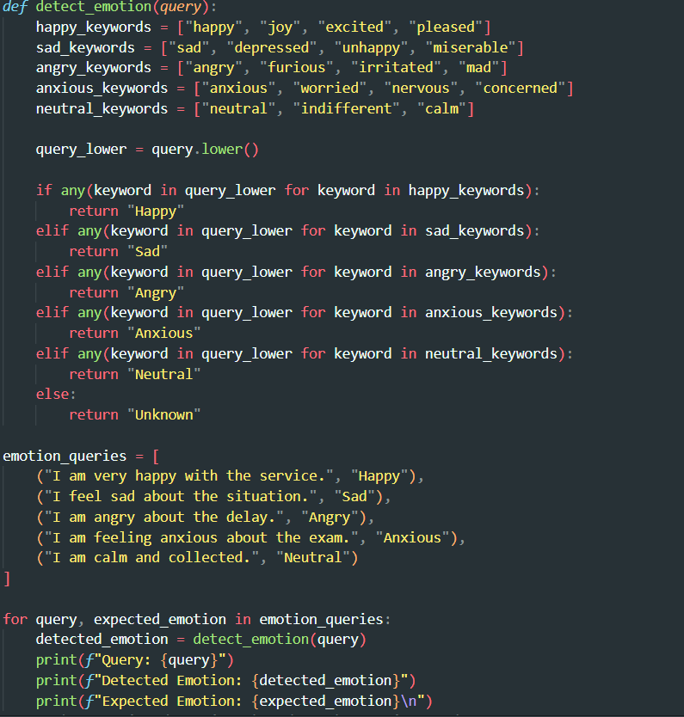

Output:
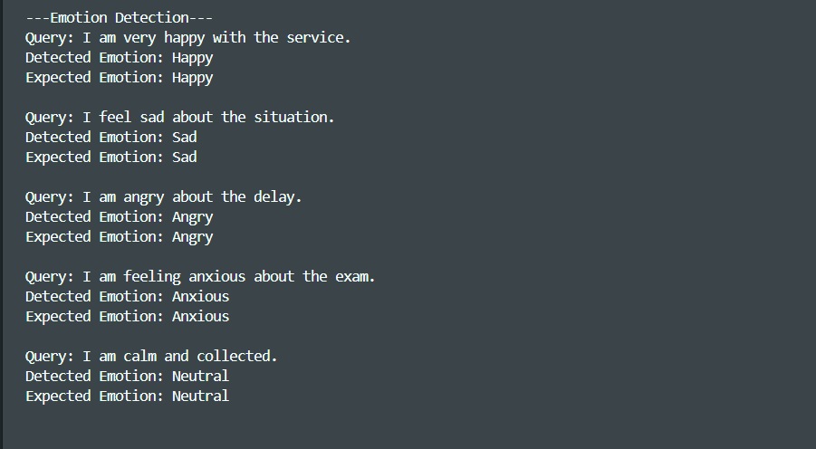
Justification:
This task detects emotions in user text using keyword matching. Each emotion is identified based on commonly used emotional words in the query. The detected emotion is compared with the expected emotion to verify correctness. This helps systems understand user feelings.
# One-shot emotion detection. based on the previous code.
Code:
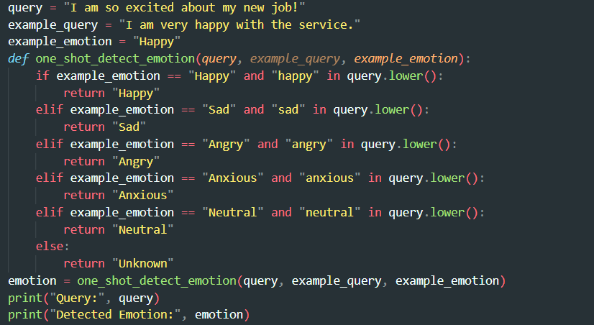
Output:
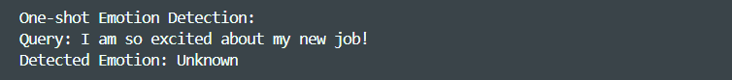
Justification:
This program detects emotion using one labeled example as guidance.
The example helps the system understand how a specific emotion is expressed in text. The input query is compared with the example using keywords. This demonstrates the concept of one-shot prompting in emotion classification.

# Few-shot emotion detection. based on the previous code.
Code:
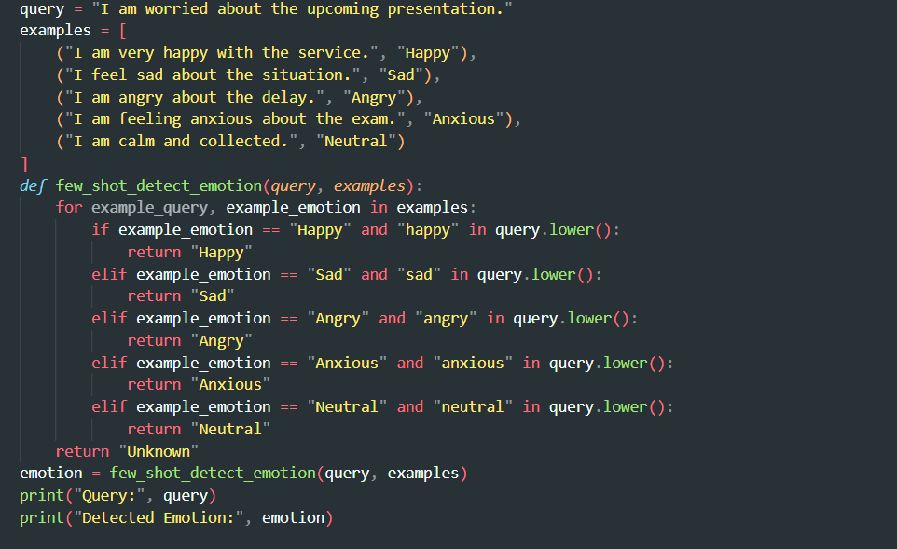
Output:

Justification:
This program identifies emotions using multiple labeled examples.
The examples help the system recognize different emotional patterns in text. The input query is compared with known emotion keywords. This improves emotion detection accuracy compared to one-shot or zero-shot methods

